**FORMAN CHRISTIAN COLLEGE (A CHARTERED UNIVERSITY)**



**Information Security (COMP 421 - B)**

**Session: Fall 2023**

**Assignment 1**

**Laiba Nusrat**

**241549070**

**GitHub Url:** [**https://github.com/LaibaNusrat/Comp421-241549070-B.git**](https://github.com/LaibaNusrat/Comp421-241549070-B.git)

[**TASK1**](https://www.offsec.com/metasploit-unleashed/port-scanning/)**:**

**Nmap & db_nmap:**

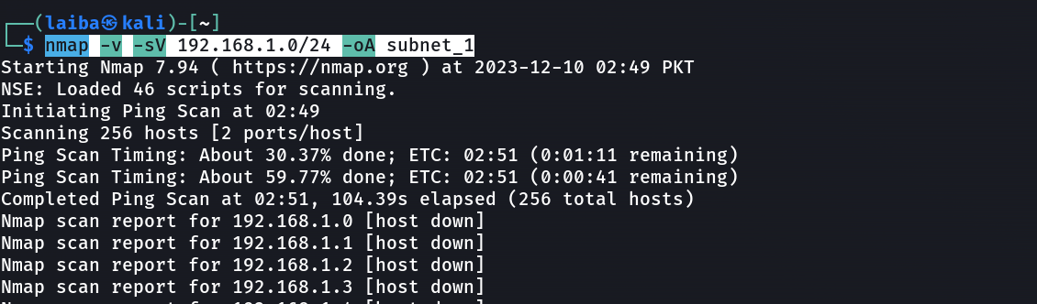

**Port Scanning:**

**SMB Version Scanning:**

**Idle Scanning:**

[**Task2**](https://www.cm-alliance.com/cybersecurity-blog/using-metasploit-and-nmap-to-scan-for-vulnerabilities)**:**

**Scanning for open ports on the client machine with Metasploit:**

